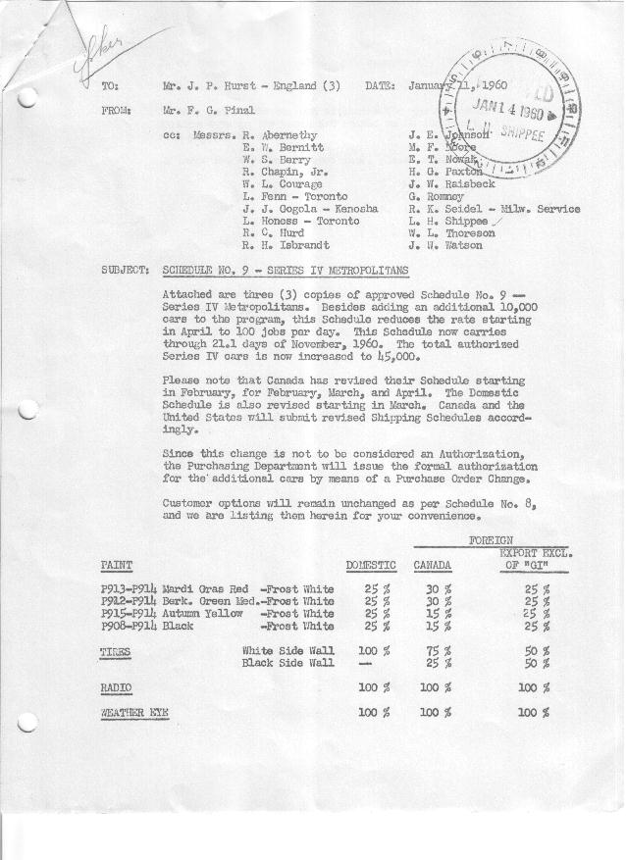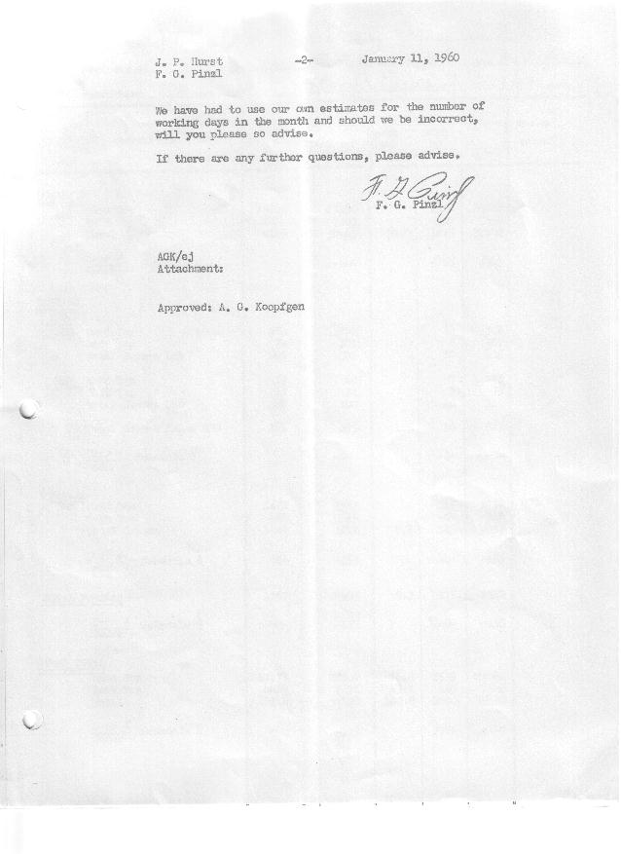

FORM AM 1262 Page 1 of 2 APPROVED R. Abernethy (signed) DATE 1-13-60

SCHEDULE NO. ______9 ___ DATE 1/11/60 MONTHLY BUILDING SCHEDULE APPROVED E.W.Bernitt (signed) DATE_ 1-13-60 _
REVISION NO. _______ __ ____ DATE PRODUCT APPROVED R. W.Chapin Jr. (signed) DATE _ 1/13/60 ____
SERIES IV 1500 c.c. ENGINE
METROPOLITAN SERIES CARS – AUSTIN MOTORS CO., LTD, ENGLAND
DESCRIPTION | BUILT  ◻ACT EST  THRU  DEC. | FIRM BUILDING SCHEDULE  (FABRICATED MATERIAL RELEASE) |  |  |  |  |  |  |  |  |  |  |  |  |  |  | TENTATIVE SCHEDULE  (RAW MATERIAL RELEASED) |  |  | GRAND  TOTAL
DESCRIPTION | BUILT  ◻ACT EST  THRU  DEC. | MONTH JANUARY ‘60  DAYS 21 |  |  | MONTH FEBRUARY  DAYS 21 |  |  | MONTH MARCH  DAYS 23 |  |  | MONTH APRIL  DAYS 19 |  |  | MONTH MAY  DAYS 22 |  |  | MONTH JUNE  DAYS 20 |  |  | GRAND  TOTAL
DESCRIPTION | BUILT  ◻ACT EST  THRU  DEC. | DAILY | MONTH | CUM’L  TOTAL | DAILY | MONTH | CUM’L  TOTAL | DAILY | MONTH | CUM’L  TOTAL | DAILY | MONTH | CUM’L  TOTAL | DAILY | MONTH | CUM’L  TOTAL | DAILY | MONTH | CUM’L TOTAL | GRAND  TOTAL
DOMESTIC LHD:
Hard-Top | 15948 |  | 1452 | 17400 |  | 1642 | 19042 |  | 1729 | 20771 |  | 1298 | 22069 |  | 1511 | 23580 |  | 1369 | 24949
Soft-Top | 4201 |  | 622 | 4823 |  | 703 | 5526 |  | 741 | 6267 |  | 432 | 6699 |  | 504 | 7203 |  | 456 | 7659
Total U.S. | 20149 | 98.8 | 2074 | 22223 | 111.7 | 2345 | 24568 | 107.4 | 2470 | 27038 | 91.1 | 1730 | 28768 | 91.6 | 2015 | 30783 | 91.3 | 1825 | 32608
Over/(Under) Schedule 8 |  |  | -0- | -0- |  | -0- | -0- |  | 100 | 100 |  | (220) | (120) |  | (320) | (440) |  | 785 | 345
FOREIGN:
EXPORT LHD Hard-Top | 224 |  | 14 | 238 |  | 14 | 252 |  | 14 | 226 |  | 14 | 280 |  | 14 | 294 |  | 14 | 308
Soft-Top | 71 |  | 6 | 77 |  | 6 | 83 |  | 6 | 89 |  | 6 | 95 |  | 6 | 101 |  | 6 | 107
Total Export LHD | 295 |  | 20 | 315 |  | 20 | 335 |  | 20 | 355 |  | 20 | 375 |  | 20 | 395 |  | 20 | 415
RHD Hard Top | 33 |  | 7 | 40 |  | 7 | 47 |  | 7 | 54 |  | 7 | 61 |  | 7 | 68 |  | 7 | 75
Soft Top | 17 |  | 3 | 20 |  | 3 | 23 |  | 3 | 26 |  | 3 | 29 |  | 3 | 32 |  | 3 | 35
Total Export RHD | 50 |  | 10 | 60 |  | 10 | 70 |  | 10 | 80 |  | 10 | 90 |  | 10 | 100 |  | 10 | 110
Total Export LHD & RHD | 345 | 1.4 | 30 | 375 | 1.4 | 30 | 405 | 1.3 | 30 | 435 | 1.6 | 30 | 465 | 1.4 | 30 | 495 | 1.5 | 30 | 525
Over/(Under) Schedule 8 |  |  | -0- | -0- |  | -0- | -0- |  | -0- | -0- |  | -0- | -0- |  | -0- | -0- |  | -0- | -0-
CANADA Hard-Top | 1272 |  | 30 | 1302 |  | -0- | 1302 |  | 70 | 1372 |  | 85 | 1457 |  | 110 | 1567 |  | 145 | 1712
Soft-Top | 150 |  | -0- | 150 |  | 30 | 180 |  | 65 | 245 |  | 55 | 300 |  | 45 | 345 |  | -0- | 345
Total Canada | 1422 | 1.4 | 30 | 1452 | 1.4 | 30 | 1482 | 5.9 | 135 | 1617 | 7.3 | 140 | 1757 | 7.0 | 155 | 1912 | 7.2 | 145 | 2057
Over/(Under) Schedule 8 | -0- |  | -0- | -0- |  | -0- | -0- |  | (100) | (100) |  | (55) | (155) |  | -0- | (155) |  | -0- | (155)
Total Foreign | 1767 | 2.8 | 60 | 1827 | 2.8 | 60 | 1887 | 7.2 | 165 | 2052 | 8.9 | 170 | 2222 | 8.4 | 185 | 2407 | 8.7 | 175 | 2582
Over/(Under) Schedule 8 | -0- |  | -0- | -0- |  | -0- | -0- |  | (100) | (100) |  | (55) | (155) |  | -0- | (155) |  | -0- | (155)
GRAND TOTALS
Hard-Top | 17477 | 71.6 | 1503 | 18980 | 79.2 | 1663 | 20643 | 79.1 | 1820 | 22463 | 73.9 | 1404 | 23867 | 74.6 | 1642 | 25509 | 76.8 | 1535 | 27044
Soft-Top | 4439 | 30.0 | 631 | 5070 | 35.3 | 742 | 5812 | 35.4 | 815 | 6627 | 6.1(26.1) | 496 | 7123 | 25.4 | 558 | 7681 | 23.2 | 465 | 8146
Total | 21916 | 101.6 | 2134 | 24050 | 114.5 | 2405 | 26455 | 114.5 | 2635 | 29090 | 100.0 | 1900 | 30990 | 100.0 | 2200 | 33190 | 100.0 | 2000 | 35190
Over/(Under) Schedule 8 | -0- |  | -0- | -0- |  | -0- | -0- | -0- | -0- | -0- |  | (275) | (275) |  | (320) | (595) |  | 785 | 190

FORM AM 1262 Page 2 of 2 APPROVED R. Abernethy (signed) DATE 1-13-60

SCHEDULE NO. ______9 ___ DATE 1/11/60 MONTHLY BUILDING SCHEDULE APPROVED E.W.Bernitt (signed) DATE_ 1-13-60 _
REVISION NO. _______ __ ____ DATE PRODUCT APPROVED R. W.Chapin Jr. (signed) DATE _ 1/13/60 ____
SERIES IV 1500 c.c. ENGINE
METROPOLITAN SERIES CARS – AUSTIN MOTORS CO., LTD, ENGLAND
DESCRIPTION | BUILT  ◻ACT◻ EST  THRU  DEC. | FIRM BUILDING SCHEDULE  (FABRICATED MATERIAL RELEASE) |  |  |  |  |  |  |  |  |  |  |  |  |  |  | TENTATIVE SCHEDULE  (RAW MATERIAL RELEASED) |  |  | GRAND  TOTAL
DESCRIPTION | BUILT  ◻ACT◻ EST  THRU  DEC. | MONTH JULY  DAYS 16 |  |  | MONTH AUGUST  DAYS 18 |  |  | MONTH SEPTEMBER  DAYS 22 |  |  | MONTH OCTOBER  DAYS 21 |  |  | MONTH NOVEMBER  DAYS 21.1 (22 Available) |  |  |  |  |  | GRAND  TOTAL
DESCRIPTION | BUILT  ◻ACT◻ EST  THRU  DEC. | DAILY | MONTH | CUM’L  TOTAL | DAILY | MONTH | CUM’L  TOTAL | DAILY | MONTH | CUM’L  TOTAL | DAILY | MONTH | CUM’L  TOTAL | DAILY | MONTH | CUM’L  TOTAL | DAILY | MONTH | CUM’L TOTAL | GRAND  TOTAL
DOMESTIC LHD:
Hard-Top |  |  | 1087 | 26036 |  | 1275 | 27311 |  | 1664 | 28975 |  | 1628 | 30603 |  | 1845 | 32448
Soft-Top |  |  | 363 | 8022 |  | 425 | 8447 |  | 416 | 8863 |  | 287 | 9150 |  | 215 | 9365
Total U.S. |  | 90.6 | 1450 | 34058 | 94.4 | 1700 | 35758 | 94.5 | 2080 | 37838 | 91.2 | 1915 | 39753 | 97.7 | 2060 | 41813
Over/(Under) Schedule 8 |  |  | 1450 | 1795 |  | 1700 | 3495 |  | 2080 | 5575 |  | 1915 | 7490 |  | 2060 | 9550
FOREIGN:
EXPORT LHD Hard-Top |  |  | 14 | 322 |  | 14 | 336 |  | 14 | 350 |  | 14 | 364 |  | 14 | 378
Soft-Top |  |  | 6 | 113 |  | 6 | 119 |  | 6 | 125 |  | 6 | 131 |  | 6 | 137
Total Export LHD |  |  | 20 | 435 |  | 20 | 455 |  | 20 | 475 |  | 20 | 495 |  | 20 | 515
RHD Hard Top |  |  | 7 | 82 |  | 7 | 89 |  | 7 | 96 |  | 7 | 103 |  | 7 | 110
Soft Top |  |  | 3 | 38 |  | 3 | 41 |  | 3 | 44 |  | 3 | 47 |  | 3 | 50
Total Export RHD |  |  | 10 | 120 |  | 10 | 130 |  | 10 | 140 |  | 10 | 150 |  | 10 | 160
Total Export LHD & RHD |  | 1.9 | 30 | 555 | 1.7 | 30 | 585 | 1.4 | 30 | 615 | 1.4 | 30 | 645 | 1.4 | 30 | 675
Over/(Under) Schedule 8 |  |  | 30 | 30 |  | 30 | 60 |  | 30 | 90 |  | 30 | 120 |  | 30 | 150
CANADA Hard-Top |  |  | 120 | 1832 |  | 70 | 1902 |  | 90 | 1992 |  | 155 | 2147 |  | 20 | 2167
Soft-Top |  |  | -0- | 345 |  | -0- | 345 |  | -0- | 345 |  | -0- | 345 |  | -0- | 345
Total Canada |  | 7.5 | 120 | 2177 | 3.9 | 70 | 2247 | 4.1 | 90 | 2337 | 7.4 | 155 | 2492 | 0.9 | 20 | 2512
Over/(Under) Schedule 8 |  |  | 120 | (35) |  | 70 | 35 |  | 90 | 125 |  | 155 | 280 |  | 20 | 300
Total Foreign |  | 9.4 | 150 | 2732 | 5.6 | 100 | 2832 | 5.5 | 120 | 2952 | 8.8 | 185 | 3137 | 2.3 | 50 | 3187
Over/(Under) Schedule 8 |  |  | 150 | (5) |  | 100 | 95 |  | 120 | 215 |  | 185 | 400 |  | 50 | 450
GRAND TOTALS
Hard-Top |  | 76.8 | 1228 | 28272 | 75.9 | 1366 | 29638 | 80.7 | 1775 | 31413 | 85.9 | 1804 | 33217 | 89.4 | 1886 | 35103
Soft-Top |  | 23.2 | 372 | 8518 | 24.1 | 434 | 8952 | 19.3 | 425 | 9377 | 14.1 | 296 | 9673 | 10.6 | 224 | 9897
Total |  | 100.0 | 1600 | 36790 | 100.0 | 1800 | 38590 | 100.0 | 2200 | 40790 | 100.0 | 2100 | 42890 | 100.0 | 2110 | 45000
Over/(Under) Schedule 8 |  |  | 1600 | 1790 |  | 1800 | 3590 |  | 2200 | 5790 |  | 2100 | 7890 |  | 2110 | 10000

